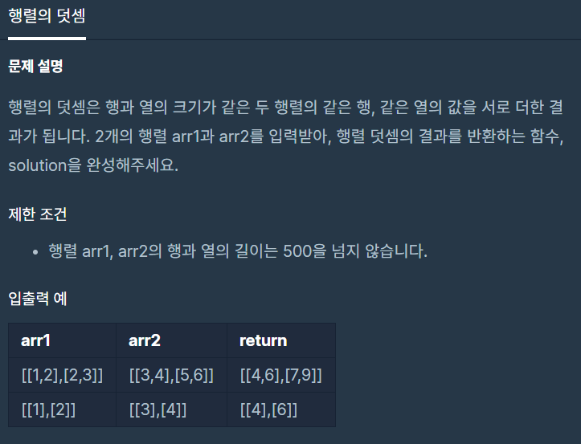

**문제 링크주소 :** <https://programmers.co.kr/learn/courses/30/lessons/12950>

**풀이**

function solution(*arr1*, *arr2*) {

    var answer = [];

    for(var i=0; i<*arr1*.length; i++){ *//0,1*

        answer.push([]);

        for(var j=0; j<*arr1*[0].length; j++){ *//0,1*

            answer[i].push(*arr1*[i][j]+*arr2*[i][j]);

        }

    }

    return answer;

}

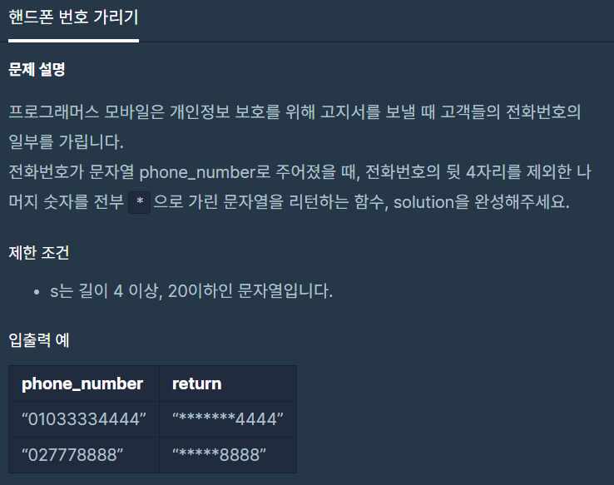

**문제 링크주소 :** <https://programmers.co.kr/learn/courses/30/lessons/12948>

**풀이**

function solution(*phone_number*) {

    var arr = [];

    for(var i=0; i<*phone_number*.length-4; i++){

        arr.push("*");

    }

    arr.push(*phone_number*.slice(-4));

    return arr.join("");

}